Smart water fountains

# Flowchart for smart water fountains

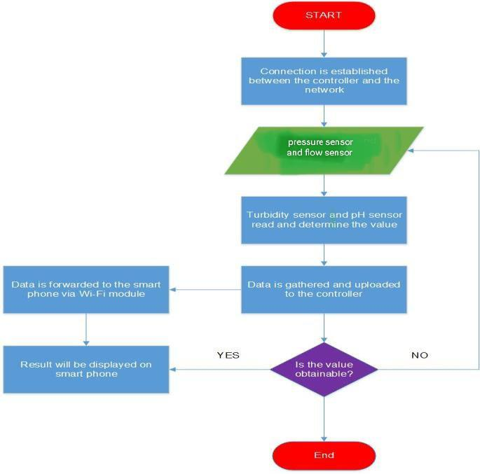

# Arduino censor definition

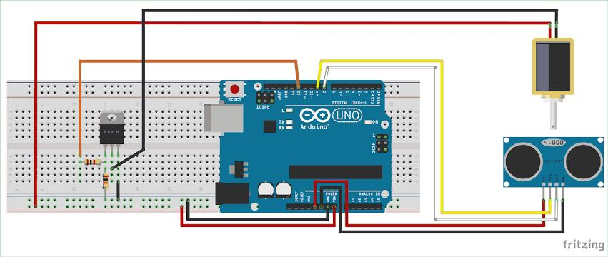

* An Arduino sensor is a specialized electronic device designed to interact with an Arduino microcontroller to collect data from the physical world. These sensors can measure various physical properties, such as temperature, humidity, light, motion, sound, distance, and more. Arduino sensors play a fundamental role in creating interactive and responsive electronic projects by providing input data to the microcontroller, which can then be used for decision-making, automation, or data analysis.

**Flow sensor:**

Modal:  YF-S201

**Pressure sensor:**

Modal : HX710B

**Block diagram key points:**

* Real-time Monitoring: Pressure and flow sensors allow for continuous monitoring of water conditions, ensuring efficient water usage.
* Water Conservation: Smart fountains can detect leaks and optimize water flow to reduce wastage, contributing to water conservation efforts.
* User Interaction: Pressure and flow data can be integrated into user interfaces, allowing users to customize fountain settings.
* Maintenance Alerts: Sensors can trigger alerts when maintenance is required, such as filter replacement or pump maintenance.
* Data Logging: These sensors can record data over time, helping track water usage patterns and performance.

# Block Diagram for smart water fountains

# 

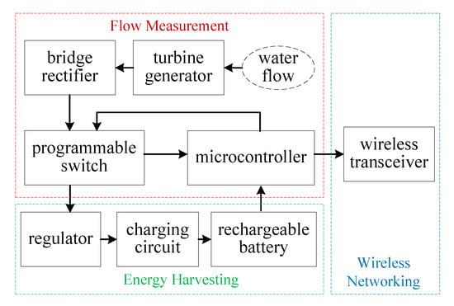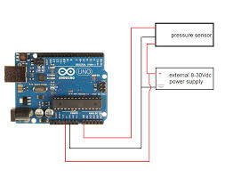

**Applications:**

**Pressure** **sensor** :

Pressure sensors are increasingly used in applications such as bottle and equipment leak detection, Variable Air Volume (VAV) systems, air blades, compressed air pressure monitoring, industrial flow monitoring, filter pressure monitoring, duct airflow, gas detection, pneumatic controls, mine safety instrumentation, ...

**Flow** **sensor :**

HVAC systems, medical devices, chemical factories, and septic systems